

Front End Web Development Plan

By Aaron, Antonella, Noel and Olivia

Finglas Training Center Front End Web Developer Traineeship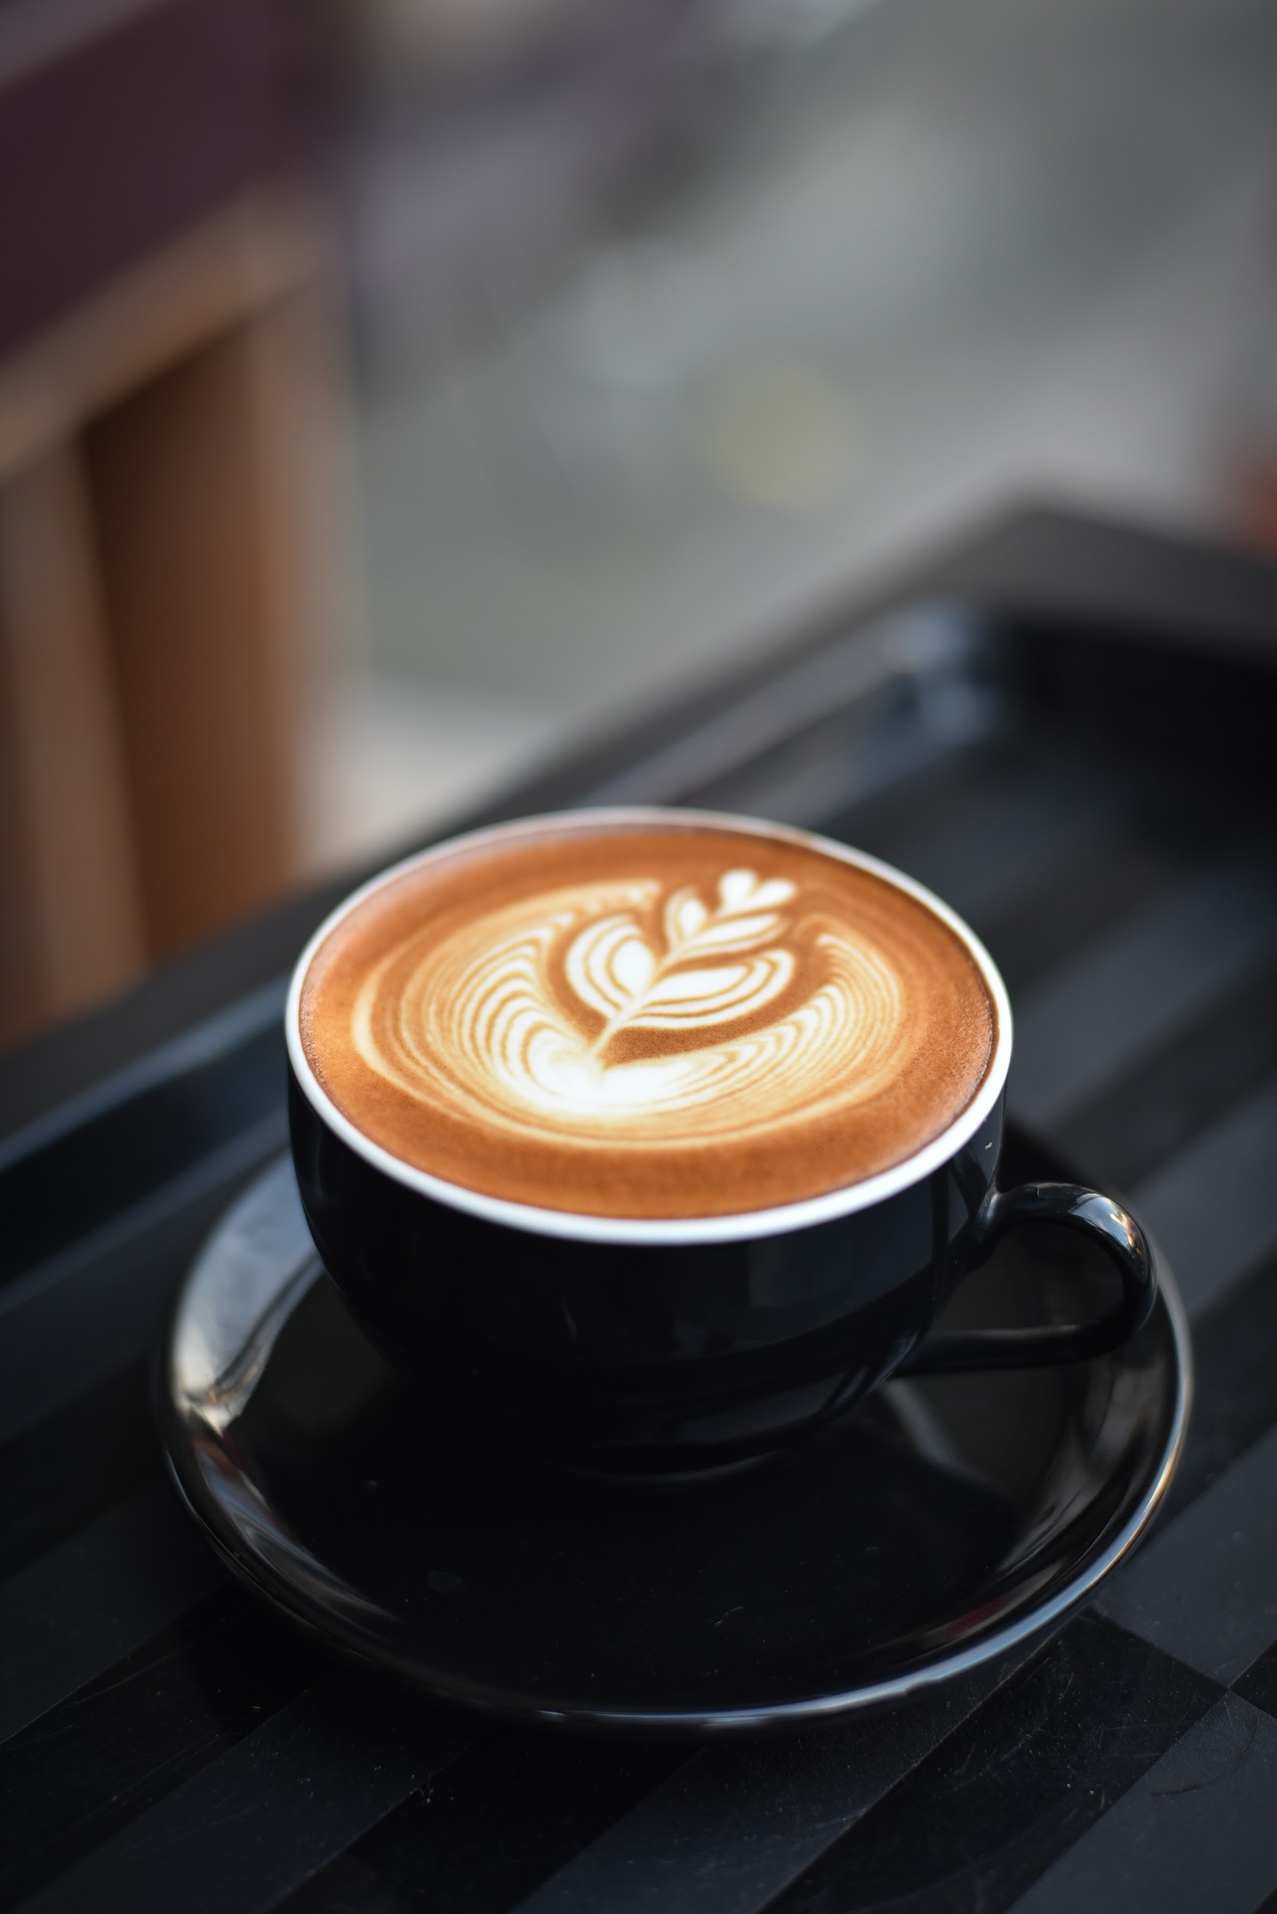

Table of Contents

[Website Name & URL 3](#_Toc33431939)

[Goals/Aims 4](#_Toc33431940)

[Objectives 4](#_Toc33431941)

[Target Audience 5](#_Toc33431942)

[Research/Concept 6](#_Toc33431943)

[Distribution of Tasks 9](#_Toc33431944)

[Site Structure/Flow Chart 11](#_Toc33431945)

[Colours 12](#_Toc33431946)

[Wireframes 13](#_Toc33431947)

[Fonts/sizes 23](#_Toc33431948)

[Specimen Sheets 25](#_Toc33431949)

[Headings 27](#_Toc33431950)

[Accessibility: 29](#_Toc33431951)

[Inventory 30](#_Toc33431952)

## Website Name & URL

The Website outlined in this Front End Web Development plan represents the brand Café Bean. Café Bean is Café located in Finglas Dublin

We picked the name for this website because we liked how it related to coffee beans and we are a coffee shop. Our Colour relates to coffee beans.

The Company name: Café Bean

The domain name: www.cafe-bean.ie

The URL:<https://www.cafe-bean.ie>

The chosen domain name is Café bean

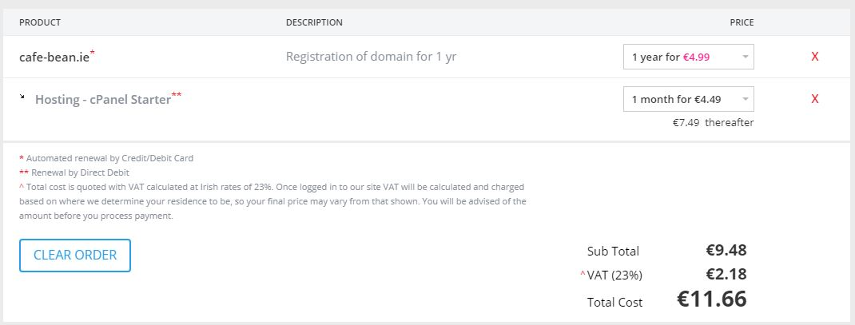

## Goals/Aims

The goal of this website is to bring attention to a new Café in the Finglas Area and ultimately bring great tasting and sustainable coffee and delicious food to The local people in Finglas

## Objectives

We will develop a fully mobile responsive website which best represents Café Bean.

The website will be developed using the latest versions of HTML5, CSS and JavaScript.

The website will have 8 page

1. **Home**

Introductory Homepage with main navigational links linking to the other areas of the website/webpage. the homepage will contain a slider of images relating to the brand

1. **About**

The about page will be dedicated to information about Café Bean. Including how they came about and what the offer

1. **Menu**

**Introductory page to the menu and choices available**

1. **Breakfast**

**Breakfast Menu detailing what breakfast options are available**

1. **Lunch**

**Lunch Menu detailing what lunch options are available**

1. **Beverages**

**Beverages Available detaining different beverages available**

1. **Sustainability**

The sustainability page relates to how the coffee sourced at Café Bean is produced sustainability

1. **Contact / Find Us**

A Contact Me section which will contain a form to contact Café Bean, an address, a phone number and any necessary social Media links.

## Target Audience

Target Audience The local people in the area of Finglas who enjoy drinking good coffee and eating delicious food.

## Research/Concept

During the research phase of this project plan, we researched other small Irish Cafés for inspiration.

Café Haven

<http://www.cafehaven.ie/cafe-menu-dublin11_breakfast-rosemount_business_park/>

**Noel** used this website as an example of a cafe website he liked

As a group, we agreed that we liked the layout of the homepage slider on the website Café Haven.ie website and decided to implement a slider into our homepage

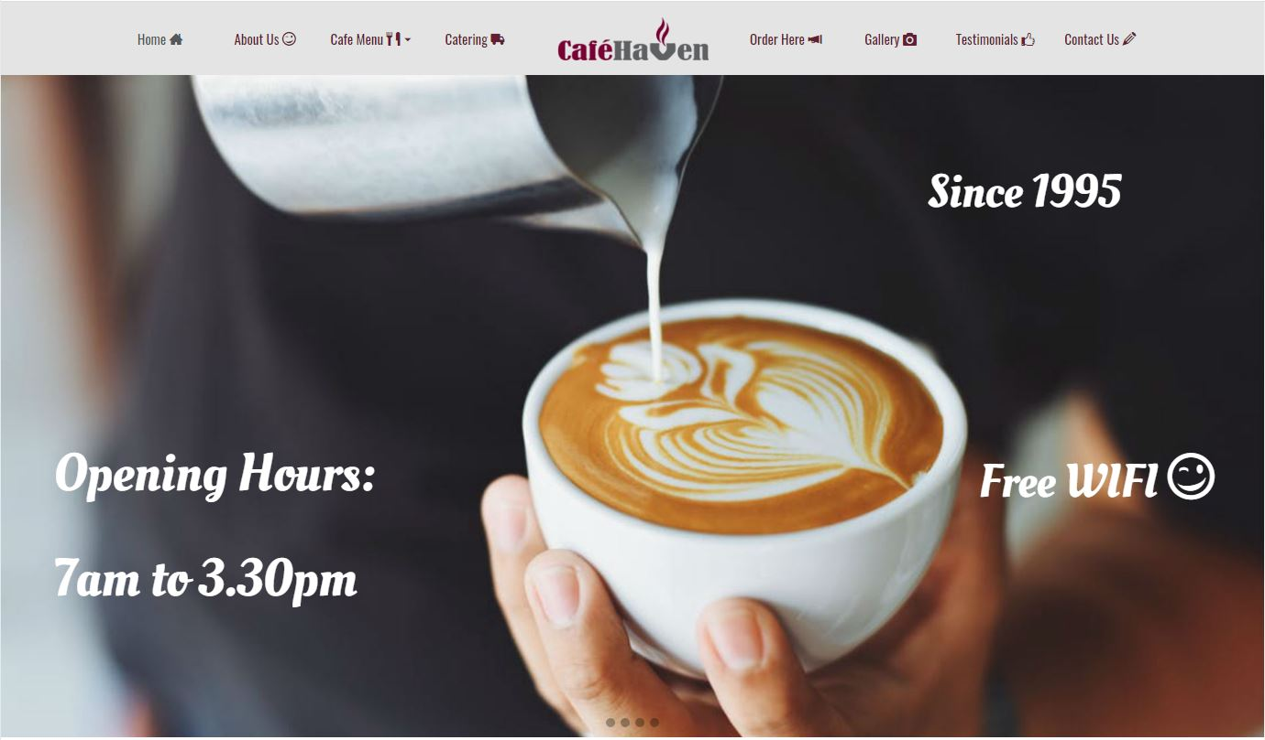

Alma

<http://www.alma.ie>

**Antonella** liked this Café website and presented it to the group.

As a group, we agreed that we liked the layout of the menu page on this website Alma.ie and decided to implement it into our design.

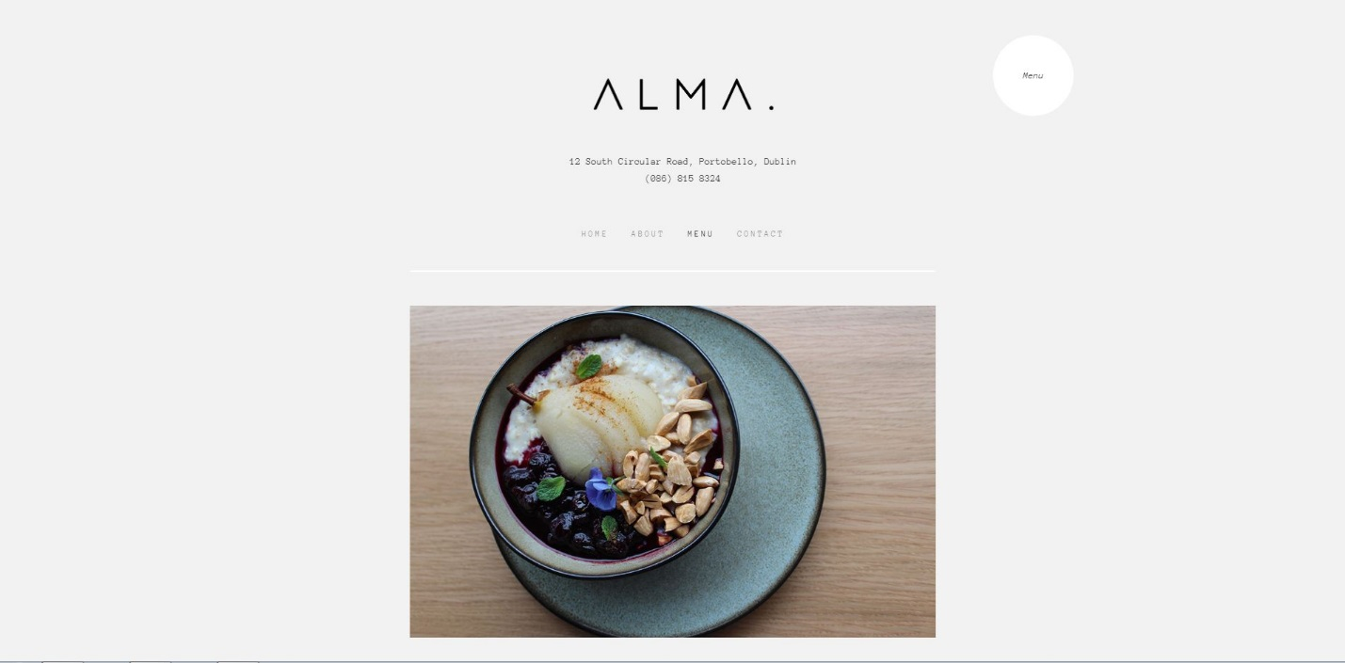

Kaph

<http://www.kaph.ie>

**Olivia** used this website as an example to show

As a group, we agreed that we liked the Big Image on the homepage on this website and decided to use it as inspiration for our website homepage slider

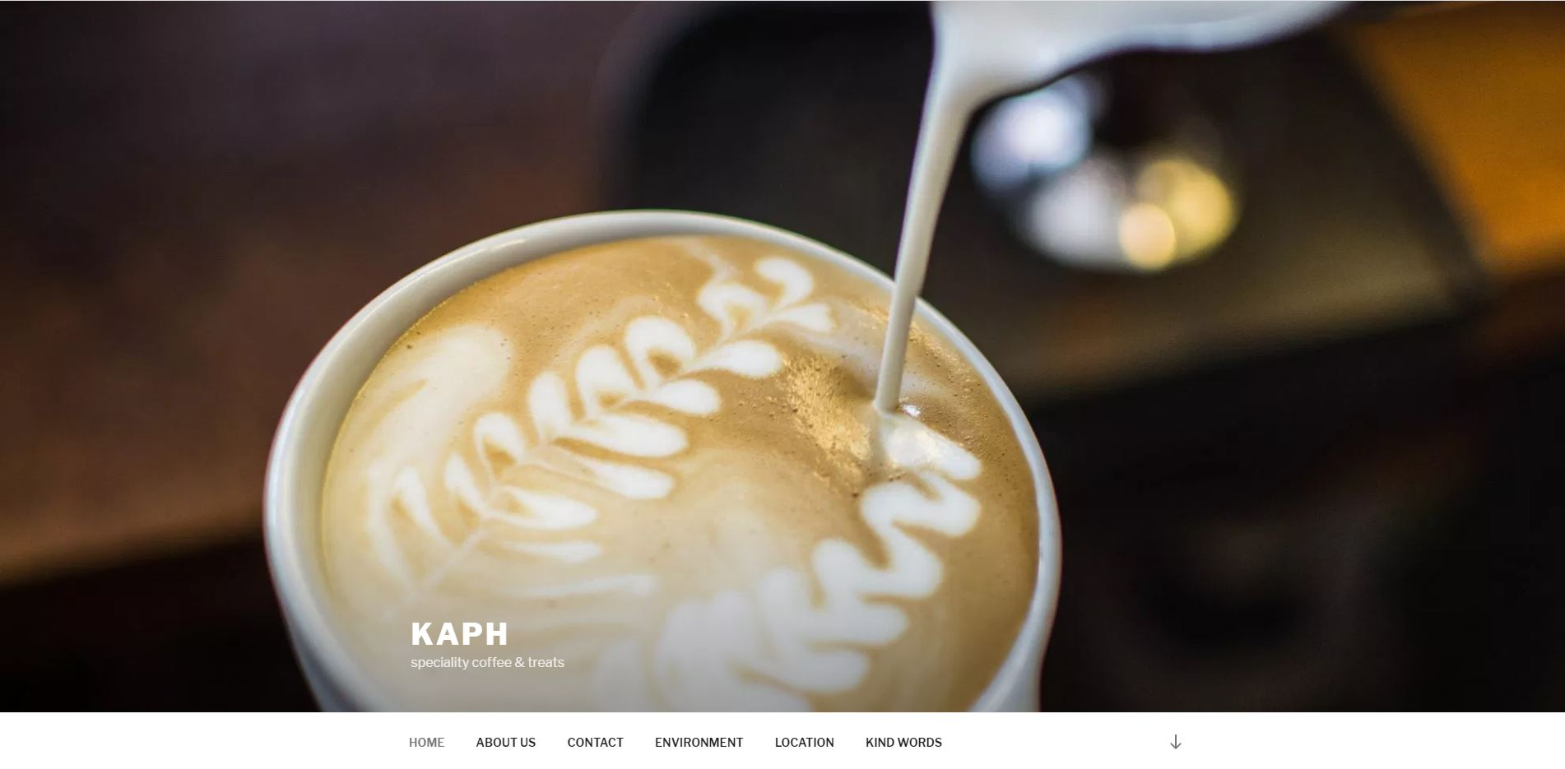

Keoghs Cafe

<https://keoghscafe.ie/>

**Aaron** used this website as an example presenting it the group. Aaron liked the photos in this website.

As a group, we agreed that we liked the layout of this website and decided to use it as inspiration for our website.

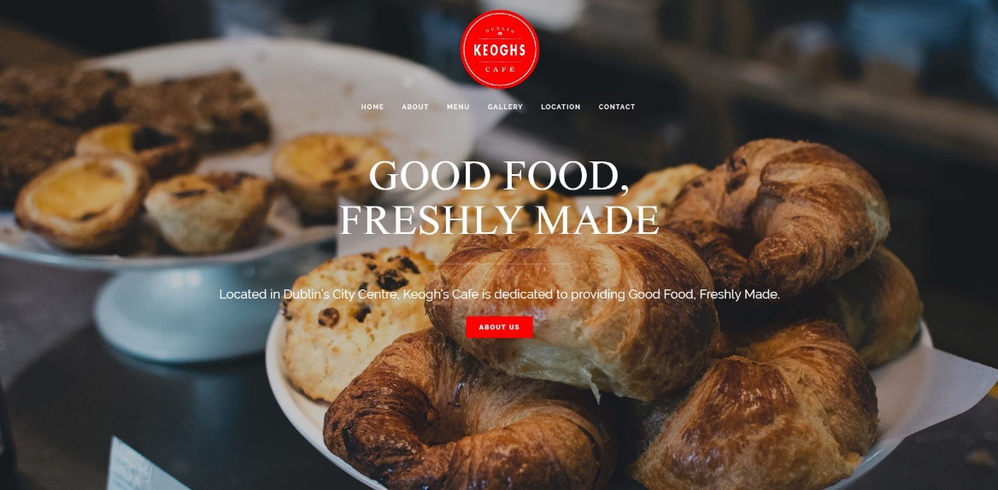

## 

## Distribution of Tasks

Antonella

Responsible for the wireframe, layout content, and development of:

beverages.html

About.html

Footer

Mobile menu

Noel

Responsible for the wireframe, layout content and development of

menu.html (downloadable pdf)

sustainability page

Olivia (Group Leader)

Responsible for gathering all content (all agreed by team members) to add to the project plan.

Responsible for the wireframe, layout content and development of: Contact page

Development of homepage (including header)

Collectively as a Group

As a group we collectively agreed on the following:

* Website Name
* Website Domain Name
* Target Audience
* Goals/Aims
* Objectives
* Layout
* Colours
* Fonts
* dimensions of the main header, container and footer
* resolution of the background images.

## Site Structure/Flow Chart

­

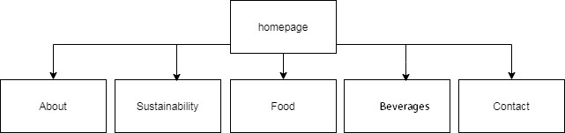

## Colours

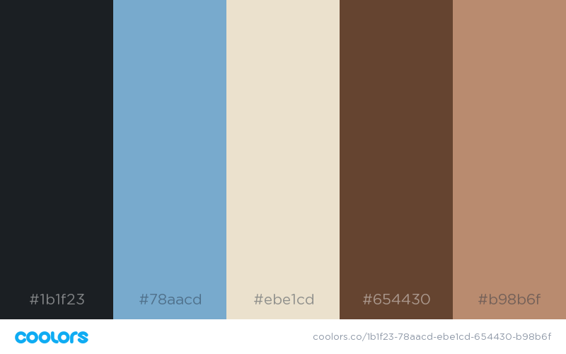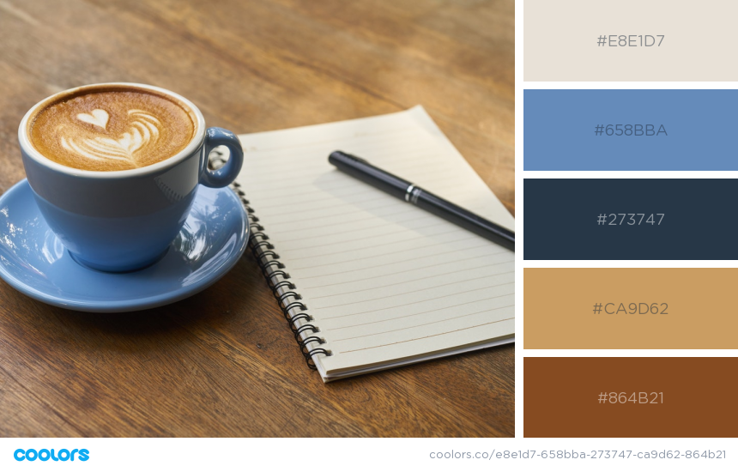

|  |  |  |  |  |
| --- | --- | --- | --- | --- |
| header | P tagline | Navigation font | <h1>Bean | <h1> span Cafe |

## Mobile Menu



## Wireframes

**Home**

**Desktop**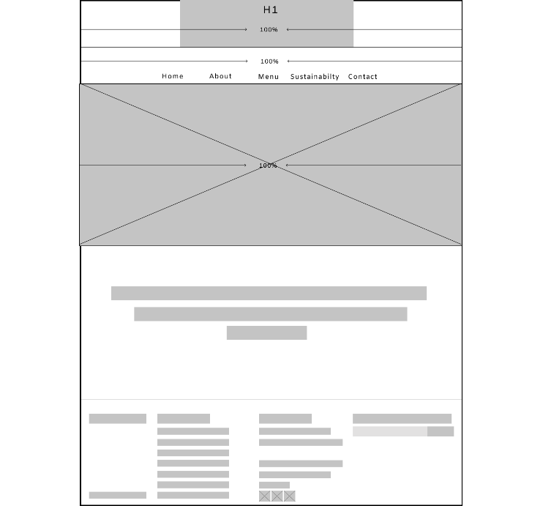

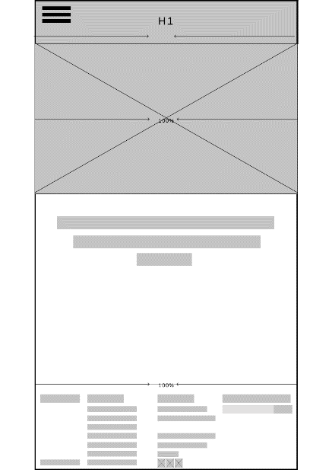**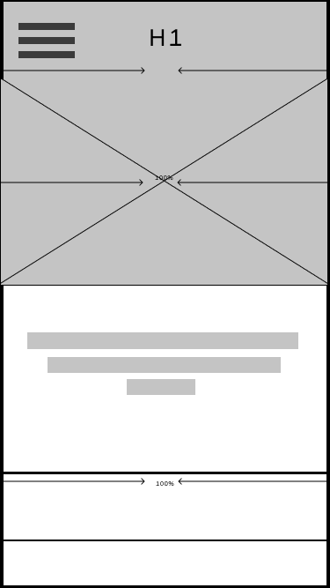**

**About**

**About.html**

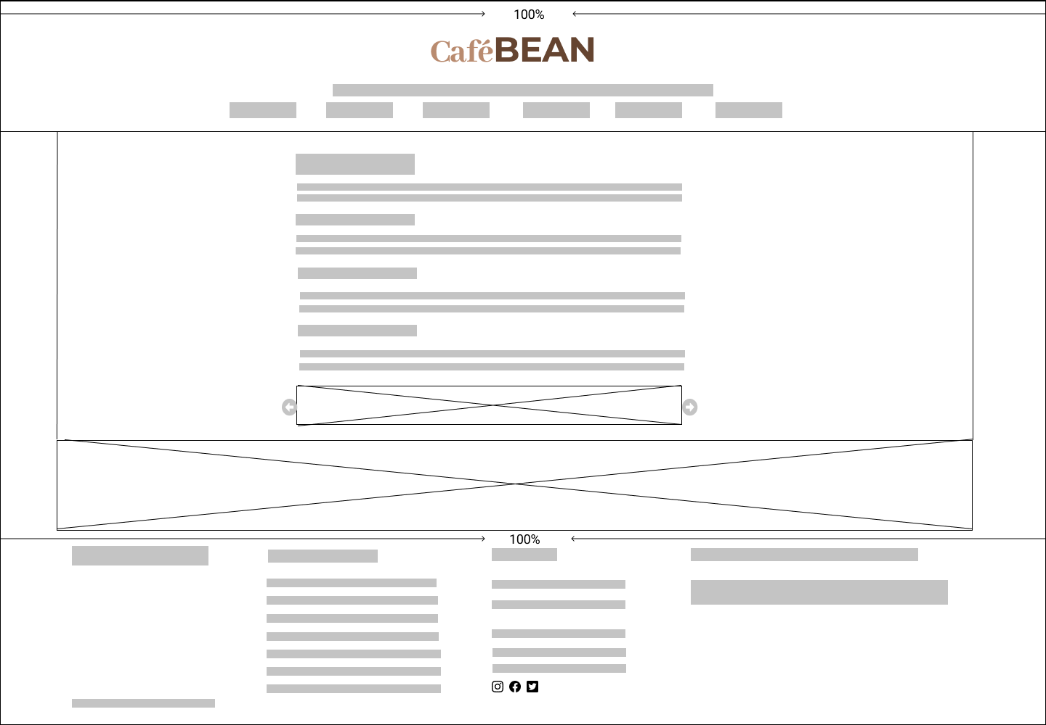

**About.html** mobile and tablet portrait (both)

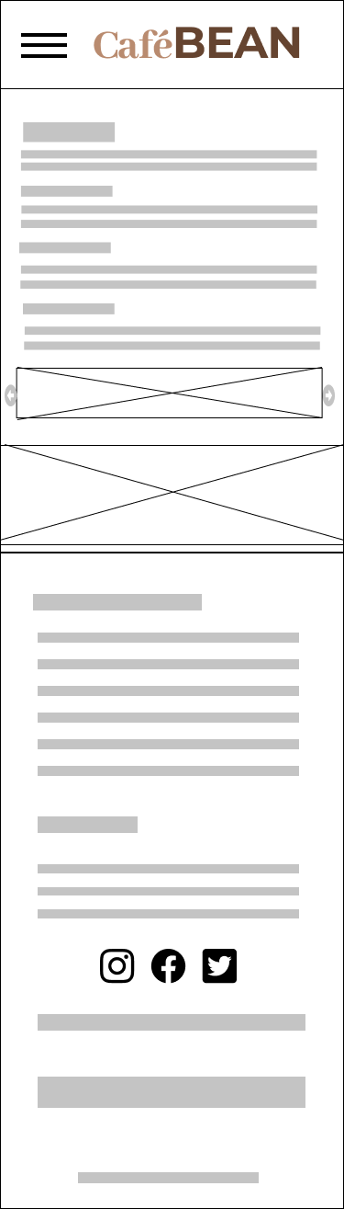

**Sustainability**

**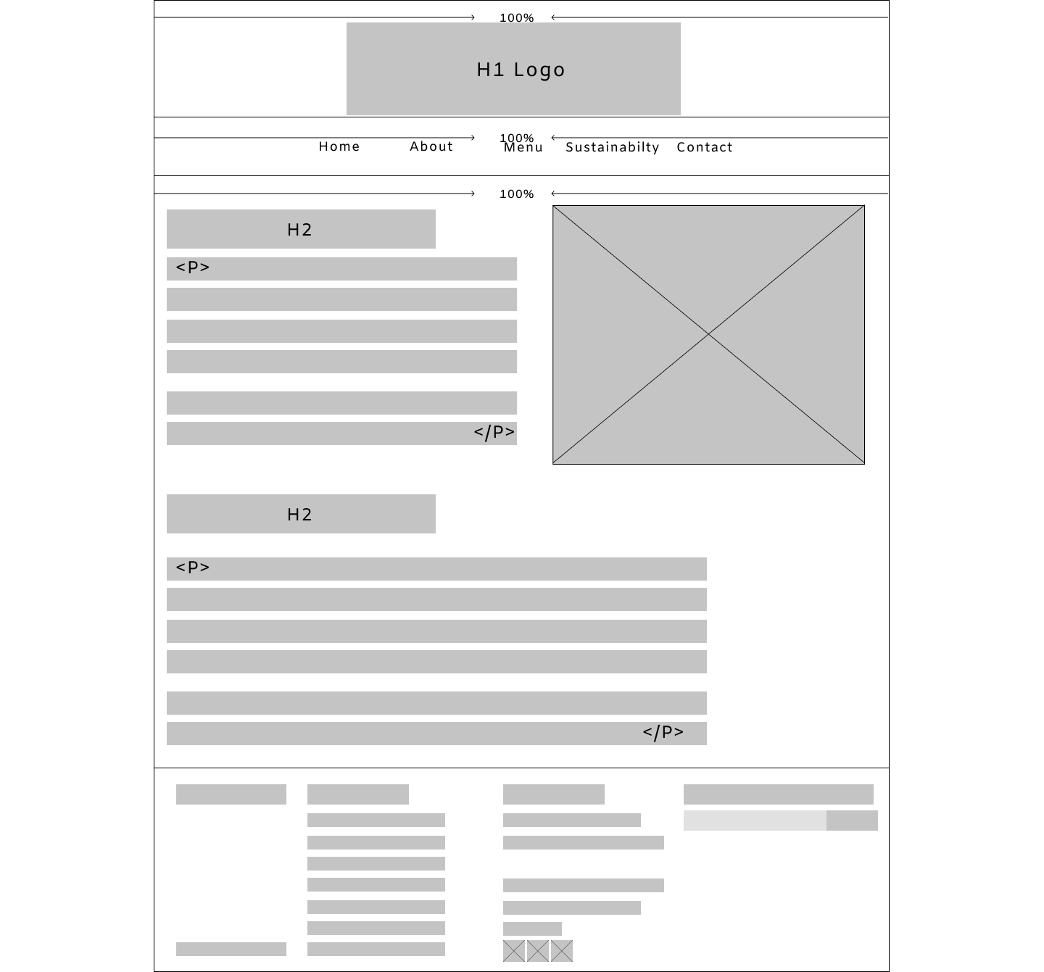 Desktop**

**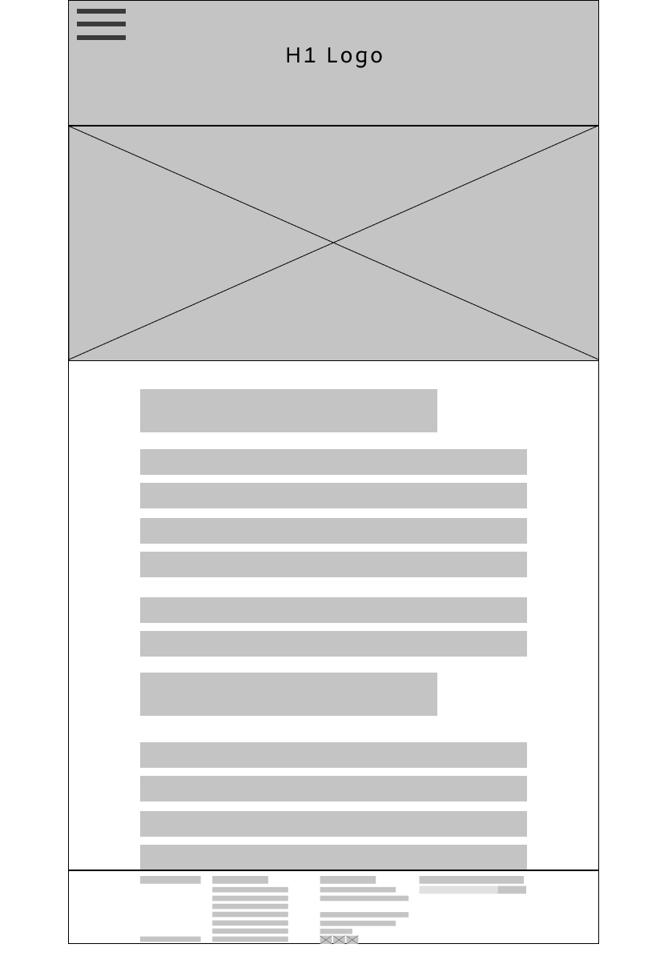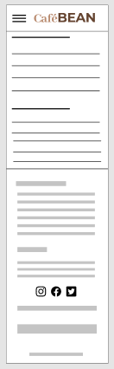**

**Tablet mobile(Noel)**

Menu

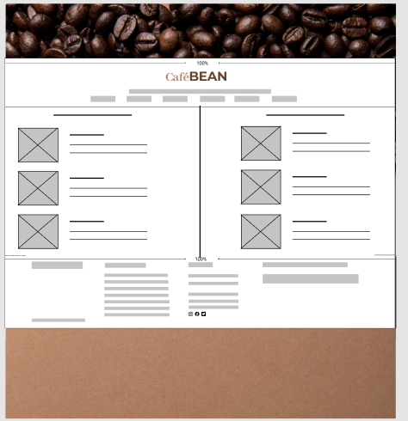

Table landscape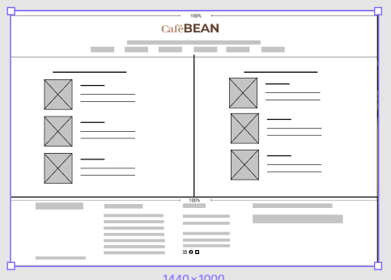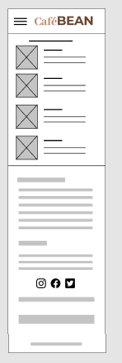mobile

**beverages.html** 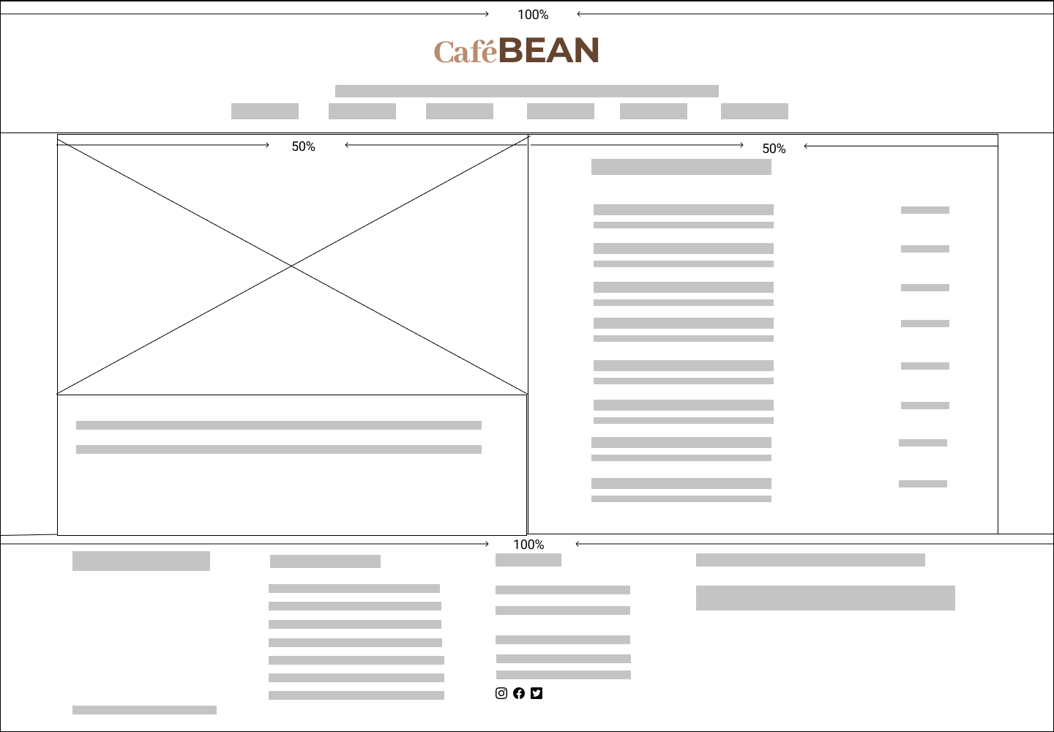desktop

**beverages.html** Tablet and mobile

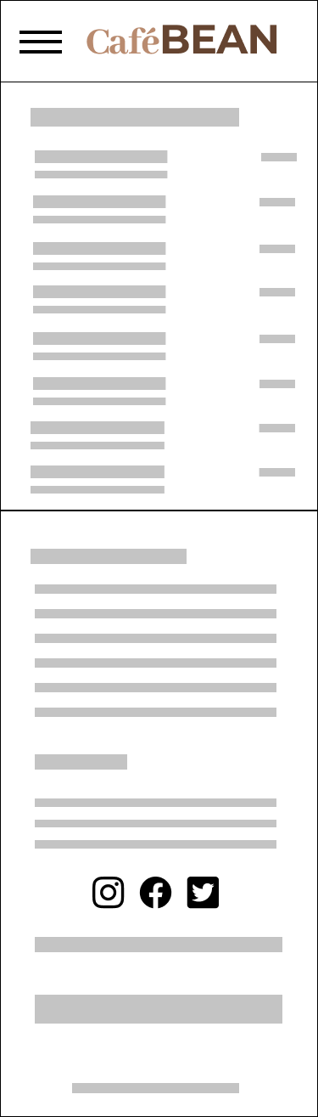

**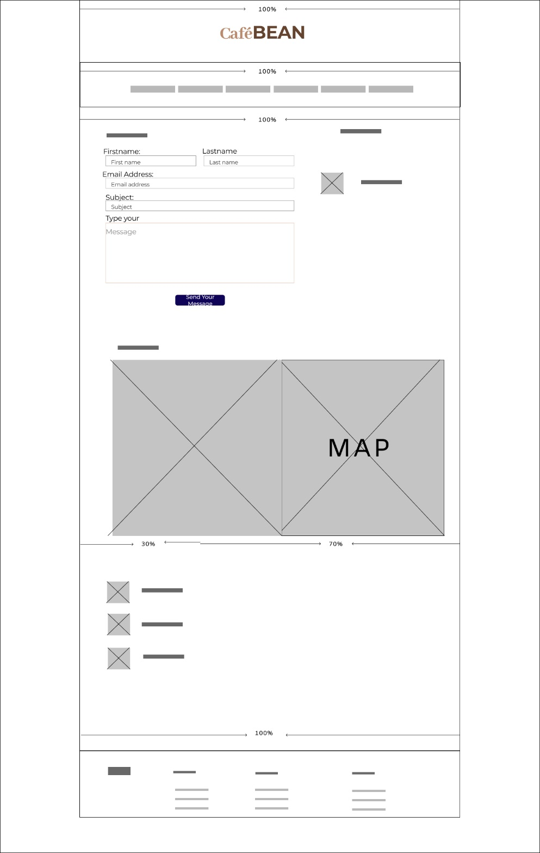 Contact Desktop 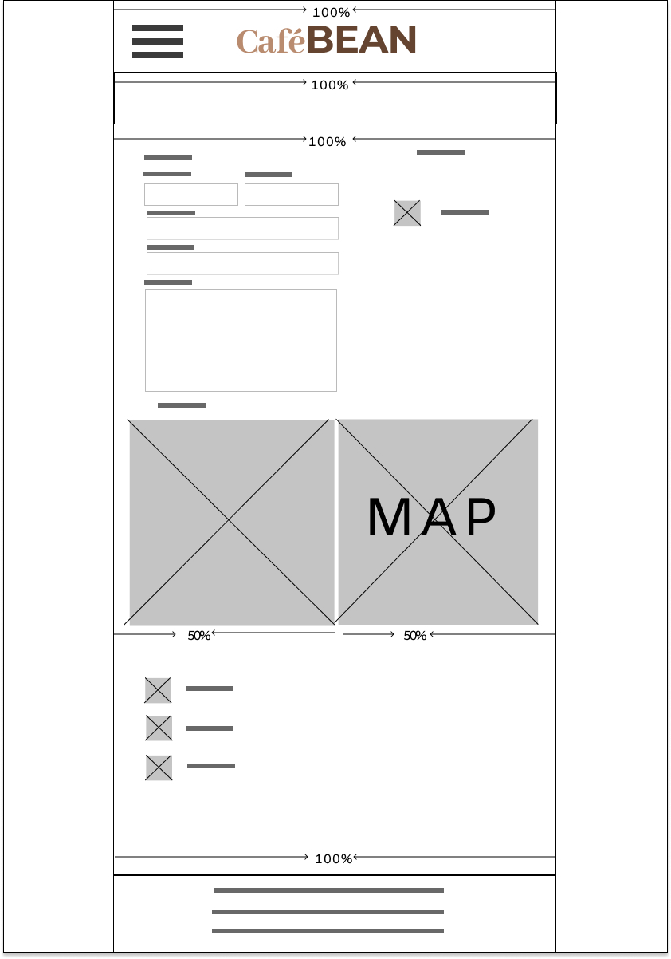**

**Tablet portrait (Contact)**

## **C:\Users\DWeb05.FASFG\Desktop\iphone (4).jpg**mobile(contact)Fonts/sizes

Reasons for choosing the Roboto for the body font because it is known for being legible across all devices.

Body

font size 14px

H1

font-size 7em

H2

font size 2.5em

H3

font size 1.25em

## Specimen Sheets

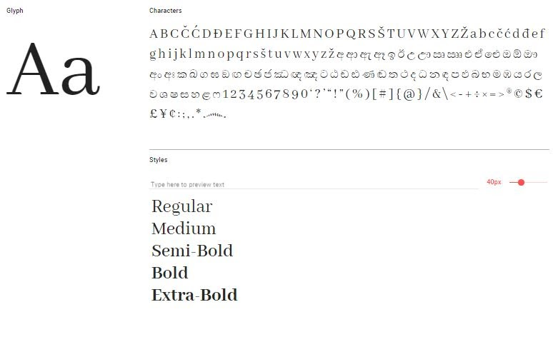

specimen Sheet

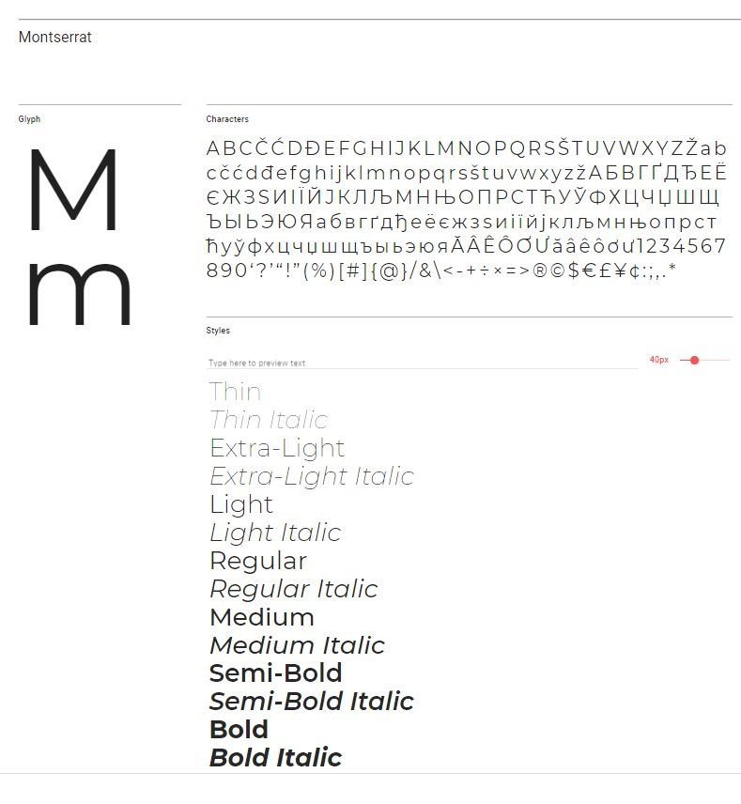

Body - Roboto Specimen Sheet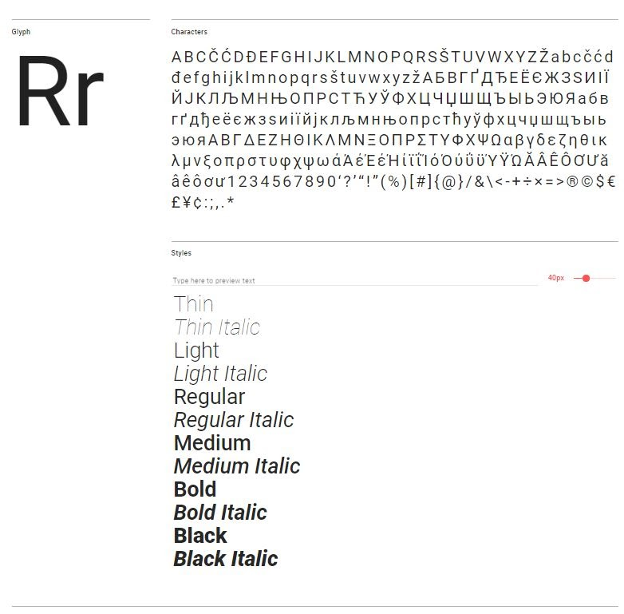

## Headings

All pages

H1 - Café Bean

Home

About

Menu

Breakfast

Lunch

Beverages

Sustainability

Contact

## Accessibility:

To make our site available to as many users as possible we have taken the following steps.

1. We are using alternative text to describe the contents of all images used on our café website.
2. We are using H1 – H3 for our headings to help give the site some structure.
3. We are using relative measurements to allow the site to be viewed on as many devices as possible.

## Inventory

**Consistent across all pages**

Footer:

Opening Hours:

Monday, Tuesday, Wednesday, Thursday, Friday, Saturday, Sunday.

9:00-22:00.

Contact:

(+353) 081 356 545

customer@cafebean.com

Poppintree Industrial Estate Jamestown Road Finglas, Dublin 11

Social Media:

Do you want to receive offers?

Email@gmail.com

Send

Copyright cafe beans 2020.

**Homepage**

Specialising in sustainble coffee and delicious food

Located in Finglas, café bean is dedicated to providing great food & freshly made coffee in a friendly atmosphere

**About.html**

We are a multi roaster Coffee Shop, bringing you a lovely variety of coffee from around the corner to around the globe.

( <https://www.lovesupreme.ie/about>)

Awash with light on even the greyest days, **Cafe beans** is the perfect place to settle in with a cup of coffee. Here you'll find expertly crafted espresso and batch brews supplied by Full Circle Roasters, teas, pastries and treats.

**Cafe beans** is super dog friendly often even making it on to our Instagram page!

We use specialty graded coffee, ensuring our customers experience a delicious cup every time.

Stop by and see what's good!

(<https://www.ebbandflow.ie/>)

COFFEE

Using seasonal blends and single origin beans roasted by the award winning Square Mile Coffee Roasters, our talented team of Baristas always strive to maximise the taste and flavour profile of every coffee we serve.

TEA

We have a decent selection of tea too if that's more your bag! We use **Great Taste Award** winning **Shibui Tea** by the pot or if you just fancy a good old fashioned brew, we can do you a mug of builder’s tea.

OUR FOOD

Our food menu includes options for Breakfast, Brunch and Lunch which are all served from 8am to 3pm Monday-Friday, 9am to 3pm Saturday and 10am to 2pm Sunday's.

We only use the best quality ingredients and source as much as we can locally.

Stop by and see what's good!

DOG FRIENDLY

We love dogs at Café Bean! So if you fancy bringing your four legged friend down for brunch or a coffee, we would LOVE IT!!! We have plenty of dog bowls and treats.

(<https://www.barebrew.co.uk/>)

**Menu**

**BLT**

Bacon, lettuce and tomato between 2 slices of wholegrain bread. €5.50.

Extras mayo €.50, red or brown sauce €.50, toasted €.50, Extra Items €1.00.

**Porridge**

<p>: Delicious hot Flahavan’s porridge is made with Irish dairy milk, ideal on a cold day €3.00. Extras: honey €.50, jam €.50, butter €.50.

**Scones**

**<p>:** Our traditional buttery rich fruit scones are delicious with fresh coffee or tea €2.00. Extras butter €.50, jam €.50.

**Full Irish**

**<p>:** 2 pieces of crispy bacon, 2 sausages, 2 pieces of pudding, 1 white and 1 black, a fried egg, 2 hash browns, baked beans, 2 slices of toast, tea or coffee €7.50. extra items €1.00 each.

French toast : 2 pieces of French toast covered in maple syrup €4.92.

Add 2 strips of bacon €2.00.

Egg on toast: 2 pieces of wholegrain bread toasted with 2 fried eggs placed on top €4.95. Add 2 strips of bacon €2.00.

Breakfast bagle: 2 strips of bacon, a fried egg placed on a toasted bagle €4.95. add 2 strips of bacon €2.00.

Panini: a fried egg and 2 strips of bacon toasted on a ciabatta

Lunch:

Spicy red pepper and tomato soup

Spicy red pepper and tomato soup accompanied with homemade brown bread

€6:00

Bean Burrito

A Mexican fiesta of a recipe, these vegetable-filled burritos are packed full of flavour and texture. This hearty dish is super easy to make and is the perfect vegetarian dish to fill you up

€8:00

BLT bagel

Yummy Bagel filled with delicious tomato, bacon and crispy lettuce.

€7:00

Chicken Sirfry

A Chinese-inspired one-pan supper with crunchy greens and nuts, and a rich chilli and soy sauce

>€9:00

Irish beef stew served in a bread bowl €11.95

Irish ham and cheese toastie: ham and cheddar cheese with wholegrain mustard on 2 slices of toasted wholegrain bread €8.95

House special salad: mixed leafs, chard, broccoli with homemade dressing €10.95.

Chicken burger: a chicken burger on a toasted bun with pimento cheese sauce and sliced pickled onions. €14.95

**beverages.html**

**Americano**

3.00

Espresso shots and light layer of crema.

Espresso shots topped with hot water create a light layer of crema culminating in this wonderfully rich cup with depth and nuance. Pro Tip: For an additional boost, ask your barista to try this with an extra shot.

**Cappuccino**

4.00

Espresso, and smoothed layer of foam.

Dark, rich espresso lies in wait under a smoothed and stretched layer of thick milk foam. An alchemy of barista artistry and craft.

**Flat White**

€2.95

Fresh brewed coffee and steamed milk.

Smooth ristretto shots of espresso get the perfect amount of steamed whole milk to create a not-too-strong, not-too-creamy, just-right flavour.

**White chocolate mocha**

€2.79

Espresso, white chocolate, milk, ice and cream.

Caramel syrup meets coffee, milk and ice for a rendezvous in the blender, while whipped cream and buttery chocolate sauce layer the love on top.

**Cafe Mocha**

3.67

Espresso whit milk, and whipped cream.

Our rich, full-bodied espresso combined with bittersweet mocha sauce and steamed milk, then topped with sweetened whipped cream. The classic coffee drink that always sweetly satisfies.

(<https://www.starbucks.com/menu>)

**Earl Grey Tea**

2.50

Water, Black Tea, Bergamot Essence, Lavender Flowers

We take a strong black tea base and add the essence of bergamot, a citrus fruit with subtle lemon and floral lavender notes, to create this aromatically awesome tea flavor.

**Royal English Breakfast Tea**

3.50

Water, A Blend of Black Teas

Each sip of this beloved morning black tea unfolds to reveal the complexity of the high-grown full leaves. An elegant, time-honored classic that brings a royal nod to every cup.

**Strawberry Açaí Lemonade**

2.30

Sweet strawberry flavors, passion fruit and açaí notes.

Sweet strawberry flavors, passion fruit and açaí notes balanced with the delightful zing of lemonade, caffeine from green coffee extract and served over ice.

**Orange juice**

3.30

The freshest orange juice.

Once you try this orange juice—cold-pressed with oranges picked and squeezed at their peak of sweetness—you'll never go back to any other. Vitamin C–packed and made with 100% juice, no added sweeteners or any artificial flavors.

**sustainability**

Creating a sustainable café

The Sustainable Restaurant Association have launched a Café Programme which as outlined in the SRA Press release, calls for cafes to ’go beyond the beans’, and demonstrate their efforts to operate as sustainable businesses. The programme provides cafés who join as members with a comprehensive assessment of the café’s sustainability based on 14 areas grouped under three categories:

Environment:

Water Saving; Workplace Resources; Waste Management; Energy Efficiency; Supply Chain.

Society:

Community Engagement; Treating People Fairly; Healthy Eating; Responsible Marketing.

Sourcing:

Environmental Positive Farming; Local & Seasonal; Ethical Meat & Dairy; Fair Trade.

Depending on the scores in each of these categories, cafes will be given a score and a rating of one, two or three stars. There are whole host of ways in which cafes can make efforts to become more sustainable. The new rating system will allow cafes to demonstrate their efforts to be more sustainable beyond their sourcing of tea and coffee.

Café Bean has been making multiple efforts to be more sustainable by doing the following:

To-Go Coffee Cups:

The thermal cover is made of recycled content and the lid is 100% recyclable. It is working with manufacturers to try to create a cup that can be recycled anywhere in the world.

Machines:

Machines are turned off when not needed to reduce carbon emissions.

Recycling:

recycle as much as they can. Recycle coffee sacks into carpet underlay. Many stores recycle organics waste and coffee grounds to create renewable fuels.

Grounds for Grounds:

Customers can request used coffee grounds for free. Can be used in the garden as a natural plant fertiliser or to add to a compost pile.

Source: https://cafespaces.wordpress.com/2016/07/27/coffee-shops-and-sustainability-coffee-cup-mountains-and-efforts-to-reduce-them/

**contact**

Text

Contact Us

Drop us a line

Firstname

Lastname

Email

Subject

Message

Call Us

(+353) 081 356 545

Drop into Us

Follow Us

Facebook

Instagram

Twitter

Address

Poppintree Industrial Estate Jamestown Road Finglas, Dublin 11

**Images:**

Consistent image used on all pages

|  |  |
| --- | --- |
| C:\Users\Dweb07.FASFG\Desktop\caffeine-coffee-coffee-beans-roasted-585750.jpg | Coffee-beans.jpg  1920x1080  549bytes |

All images below are for the slider on the home page.

|  |  |
| --- | --- |
| C:\Users\DWeb05.FASFG\Desktop\cafe-bean-master\images\slider\coffee-cup.jpg | Slider Image: coffee-cup.jpg  1280 x 853  79.8KB  Sourced on Pexels.com |
| C:\Users\DWeb05.FASFG\Desktop\cafe-bean-ok\images\index-slider\close-up-of-hand.jpg | Slider Image: close-up-of-hand. jpg  1280 x 853  114KB  Sourced from Pexels |
| C:\Users\Dweb07.FASFG\Desktop\assorted-variety-of-foods-on-plates-on-dining-table-1528013.jpg | Slider Image: variety-of-foods.jpg  1280 x 853  325kb  Sourced from Pexels |
| C:\Users\Dweb07.FASFG\Desktop\Cafe Bean\vintage-table.jpg | Slider Image: vintage-table.jpg  1280 x 853  208KB  Sourced from Pexels |
| C:\Users\DWeb05.FASFG\Desktop\cafe-bean-ok\images\index-slider\people-sitting-in-cafe.jpg | Slider Image: people-sitting-in-cafe.jpg  1280 x 853  170KB  Sourced from Pexels |
| C:\Users\DWeb05.FASFG\Desktop\cafe-bean-ok\images\index-slider\barista.jpg | Slider Image: barista.jpg  1280 x 853  346KB  Sourced from Pexels |

All images below are for the Sustainability page

|  |  |
| --- | --- |
| C:\Users\Dweb07.FASFG\Desktop\Cafe Bean\tree-love.jpg | Sustainability Image: tree-love.jpg 640x426 107KB  Sourced from Pexels |

beverages.html:

|  |  |
| --- | --- |
| C:\Users\DWeb13\Desktop\Downloads\images\beverages\americano.jpg | americano.jpeg  1050x700  62.7 kb  <https://unsplash.com/photos/FkNfVgHVzkI> |
| C:\Users\DWeb13\Desktop\Downloads\images\beverages\cafe-mocha.jpg | Cafe-mocha.jpeg  1041x703  94.9 kb  <https://unsplash.com/photos/3jW_5qHlFBE> |
| C:\Users\DWeb13\Desktop\Downloads\images\beverages\cappuccino.jpg | cappuccino.jpeg  1035x704  97.4 kb  <https://unsplash.com/photos/kSlL887znkE> |
| C:\Users\DWeb13\Desktop\Downloads\images\beverages\flat-white.jpg | Flat-white.jpeg  960x640  66.1 kb  <https://pixabay.com/photos/coffee-cafe-hot-mug-cup-white-2589759/> |
| C:\Users\DWeb13\Desktop\Downloads\images\beverages\white-chocolate-mocca.jpg | White-chocolate-mocca.jpeg  1081x692  70.5 kb  <https://unsplash.com/photos/QeZe7OHjvVY> |
| C:\Users\DWeb13\Desktop\group-project-cafe\images\beverages\green-tea.jfif | Green-tea.jpeg  600x364  39 kb  <https://unsplash.com/photos/Jzt7oV_VsBE> |
| C:\Users\DWeb13\Desktop\group-project-cafe\images\beverages\teas.jfif | teas.jpeg  600x400  21.3 kb  <https://unsplash.com/photos/4Ia348kvX7A> |
| C:\Users\DWeb13\Desktop\group-project-cafe\images\beverages\herbal-tea.jfif | Herbal-tea  600x400  33.8 kb  <https://unsplash.com/photos/rnkaQvfo1ps> |
| C:\Users\DWeb13\Desktop\group-project-cafe\images\beverages\soft-drinks.jfif | Soft-drinks  600x400  46.2 kb  <https://unsplash.com/photos/azwmrA7bdyM> |
| C:\Users\DWeb13\Desktop\group-project-cafe\images\beverages\orange-juice.jfif | Orange-juice  600x900  22.8 kb  <https://unsplash.com/photos/IgGFNg-xPJs> |

About.html

|  |  |  |
| --- | --- | --- |
| C:\Users\DWeb13\Desktop\Downloads\images\beverages\coffee-beans-about.jpg | Coffee-beans-about.jpeg  1256x958  313 kb  <https://unsplash.com/photos/TD4DBagg2wE> | |
| C:\Users\DWeb13\Desktop\group-project-cafe\images\about\breakfast.jfif | | Breakfast.jpg  600x400  65.6 kb  [https://unsplash.com/photos/URSho6okPfs](https://unsplash.com/photos/URSho6okPfs(breakfast)) | |
| C:\Users\DWeb13\Desktop\group-project-cafe\images\about\cafe.jfif | | Café.jpg  757x500  61.5 kb  <https://unsplash.com/photos/ItaV89TNkks> | |
| C:\Users\DWeb13\Desktop\group-project-cafe\images\about\coffee-about.jfif | | Coffee-flavours.jpg  750x500  55.4 kb  <https://unsplash.com/photos/6VhPY27jdps> | |
| C:\Users\DWeb13\Desktop\group-project-cafe\images\about\coffee-maker.jfif | | Coffee-maker.jpg  600x400  20.7 kb  <https://unsplash.com/photos/ItaV89TNkks> | |
| C:\Users\DWeb13\Desktop\group-project-cafe\images\about\coffee-shop.jfif | | Coffee-shop.jpg  730x500  99.2 kb  <https://unsplash.com/photos/tKN1WXrzQ3s> | |
| C:\Users\DWeb13\Desktop\group-project-cafe\images\about\lunch.jfif | | Lunch.jpg  600x410  38.3 kb  <https://unsplash.com/photos/tKN1WXrzQ3s> | |
| C:\Users\DWeb13\Desktop\group-project-cafe\images\about\pet-friendly.jfif | | Pet-friendly.jpg  600x400  34.7 kb  <https://unsplash.com/photos/n7_-Qm-Ej1o> | |
| C:\Users\DWeb13\Desktop\group-project-cafe\images\about\waiter.jfif | | Waiter.jpg  600x400  45.6 kb  <https://unsplash.com/photos/e5Q5vWO55uU> | |
| C:\Users\DWeb13\Desktop\group-project-cafe\images\about\waiters.jfif | | Costumers.jpg  600x400  70.6 kb  <https://unsplash.com/photos/f7zm5TDOi4g> | |

Images:

Contact.html images

­­­­

|  |  |
| --- | --- |
| C:\Users\DWeb05.FASFG\Desktop\cafe-bean-master\images\contact\twitter-icon.png | Filename: twitter-icon.png  File size: 1.42kb  Dimensions: 50 x 50 |
| C:\Users\DWeb05.FASFG\Desktop\cafe-bean-master\images\contact\facebook-icon.png | Filename: facebook-icon.png  File size: 1.34kb  Dimensions: 50 x 50 |
| C:\Users\DWeb05.FASFG\Desktop\cafe-bean-master\images\contact\instagram-icon.png | Filename: instagram-icon.png  File size: 1.56kb  Dimensions: 50 x 50 |
| C:\Users\DWeb05.FASFG\Desktop\table-in-vintage-restaurant-6267.jpg | Filename: cafe.jpg  File size: 1.42kb  Dimensions: 150 x 50  Sourced from Pexels |
|  |  |

menu.html images

|  |  |
| --- | --- |
| G:\menuphotos\bean-burrito.jpg | Filename: bean-burrito.jpg  File size: 13.7kb  Dimensions: 150 x 150  Sourced from Pexels |
| G:\menuphotos\blt.PNG | Filename: blt.jpg  File size: 509kb  Dimensions: 516 x 421  Sourced from Bing |
| G:\menuphotos\beef-stew.PNG | Filename: beef-stew.jpg  File size: 34.6kb  Dimensions: 155 x 191  Sourced from Bing |
| G:\menuphotos\breakfastbagle.PNG | Filename: breakfastbagel.jpg  File size: 34.6kb  Dimensions: 867 x 660  Sourced from Bing |
| G:\menuphotos\cajun-chicken-bagel.jpg | Filename: cajun-chicken-bagel.jpg  File size: 26kb  Dimensions: 500 x 333  Sourced from Bing |
| G:\menuphotos\chicken-burger.PNG | Filename: chicken-burger.jpg  File size: 26kb  Dimensions: 500 x 333  Sourced from Bing |
| G:\menuphotos\eggontoast.PNG | Filename: eggontoast.jpg  File size: 26kb  Dimensions: 1506 x 655  Sourced from Bing |
| G:\menuphotos\frenchtoast.PNG | Filename: frenchtoast.jpg  File size: 1.91mb  Dimensions: 1183x 659  Sourced from Bing |

|  |  |
| --- | --- |
| G:\menuphotos\fullirish.PNG | Filename: fullirish.jpg  File size: 714kb  Dimensions: 644 x 480  Sourced from Bing |
| G:\menuphotos\ham-cheese.PNG | Filename: hamcheese.jpg  File size: 34.9kb  Dimensions: 166x147  Sourced from Bing |
| G:\menuphotos\house-salad.PNG | Filename: house-salad.jpg  File size: 33.5kb  Dimensions: 146 x 134  Sourced from Bing |
| G:\menuphotos\panini.PNG | Filename: panini.jpg  File size: 1.64mb  Dimensions: 1099x664  Sourced from Bing |
| G:\menuphotos\porridge.PNG | Filename: porridge.jpg  File size: 1.91mb  Dimensions: 1183x 659  Sourced from Bing |
| G:\menuphotos\red-pepper-soup.jpg | Filename: red-pepper-soup.jpg  File size: 23.4kb  Dimensions: 254 x 261  Sourced from Pexels |
| G:\menuphotos\stirfry.jpg | Filename: stirfry.jpg  File size: 14.0kb  Dimensions: 137x 132  Sourced from Bing |
| G:\menuphotos\scones.PNG | Filename: frenchtoast.jpg  File size: 1.25mb  Dimensions: 887x 669  Sourced from Bing |

## C:\Users\DWeb05.FASFG\Downloads\screencapture-file-C-Users-DWeb05-FASFG-Desktop-cafe-bean-master-index-html-2020-02-26-15_22_27.pngScreenshots of Café-bean.ie

Desktop Homepage

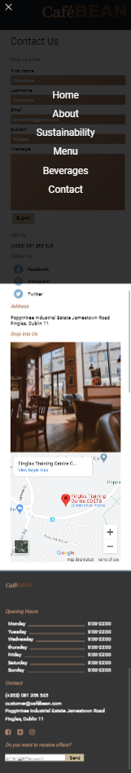

Mobile Menu Open

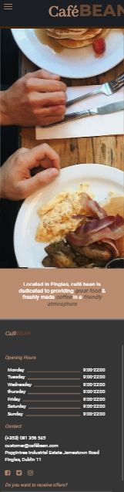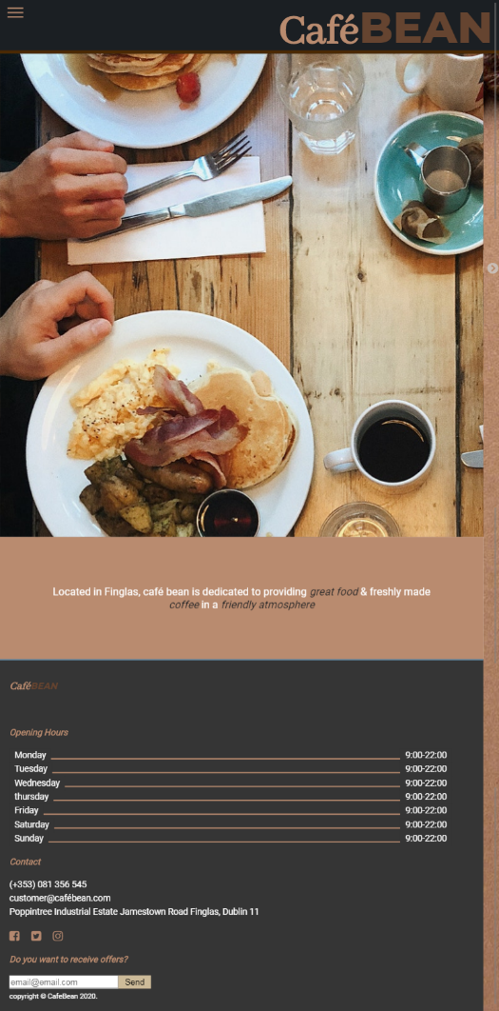

Mobile Homepage

Tablet Homepage

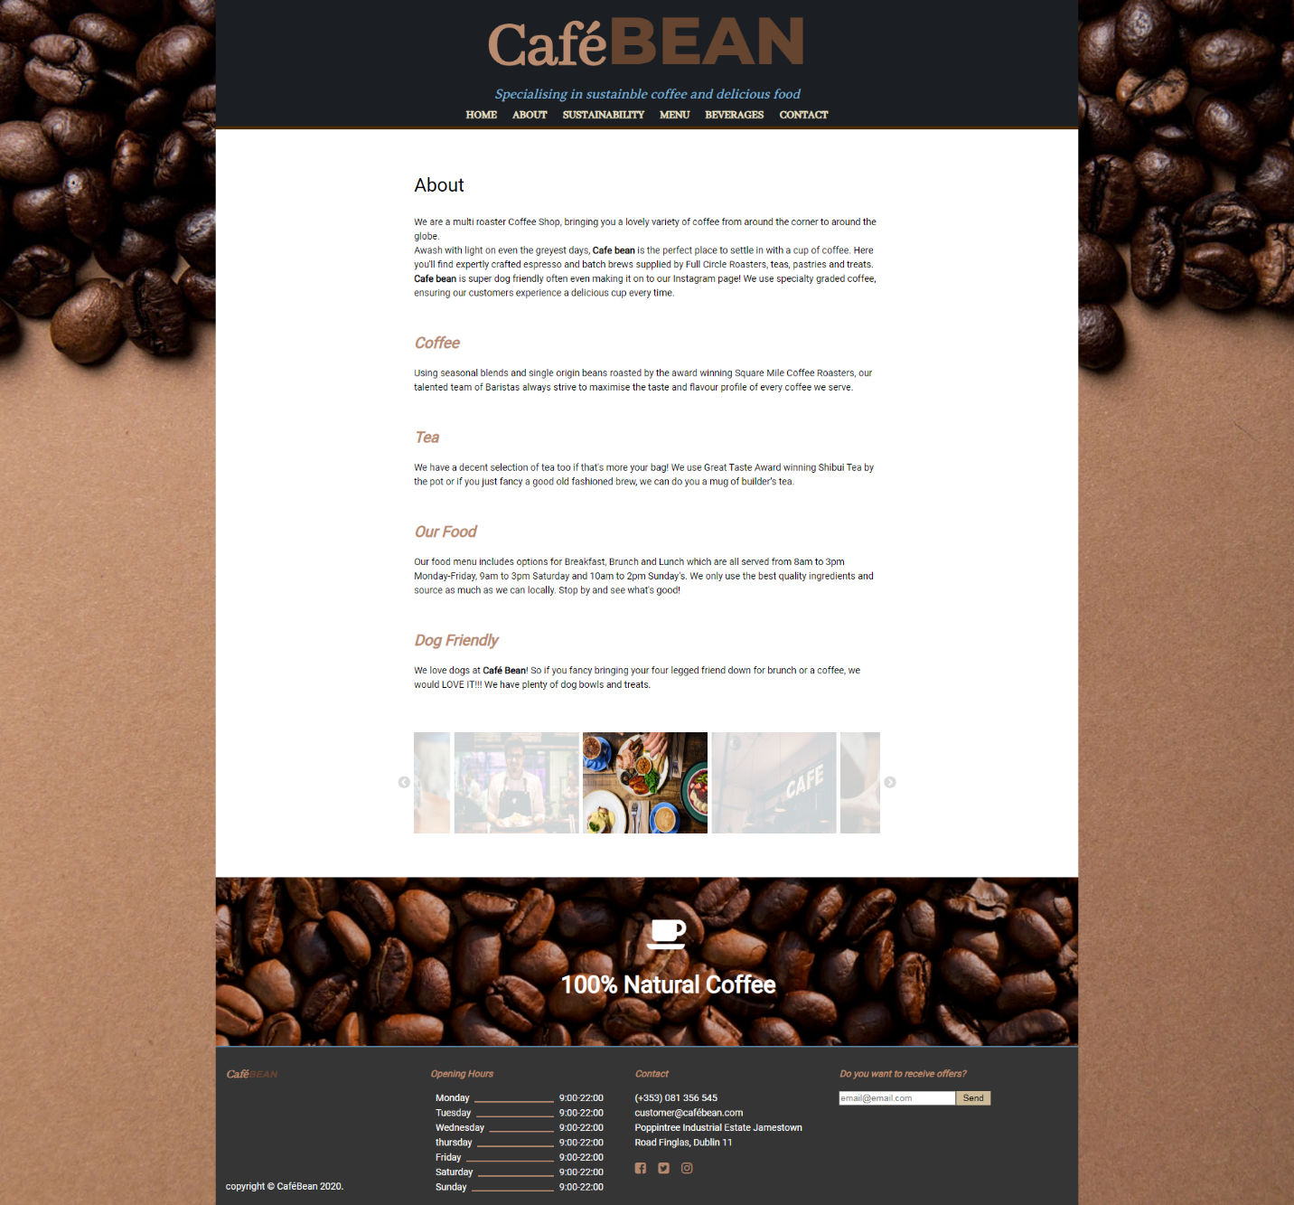

Desktop - About

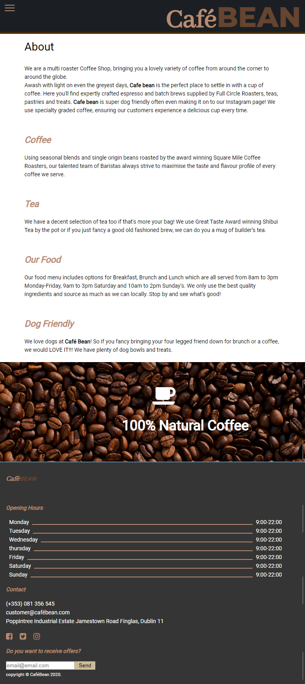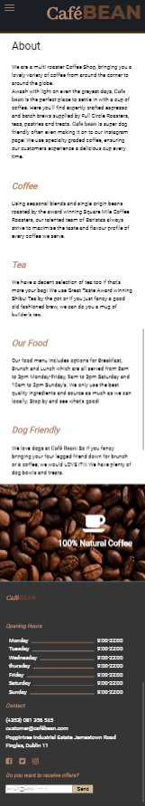

Tablet - About

Mobile – About

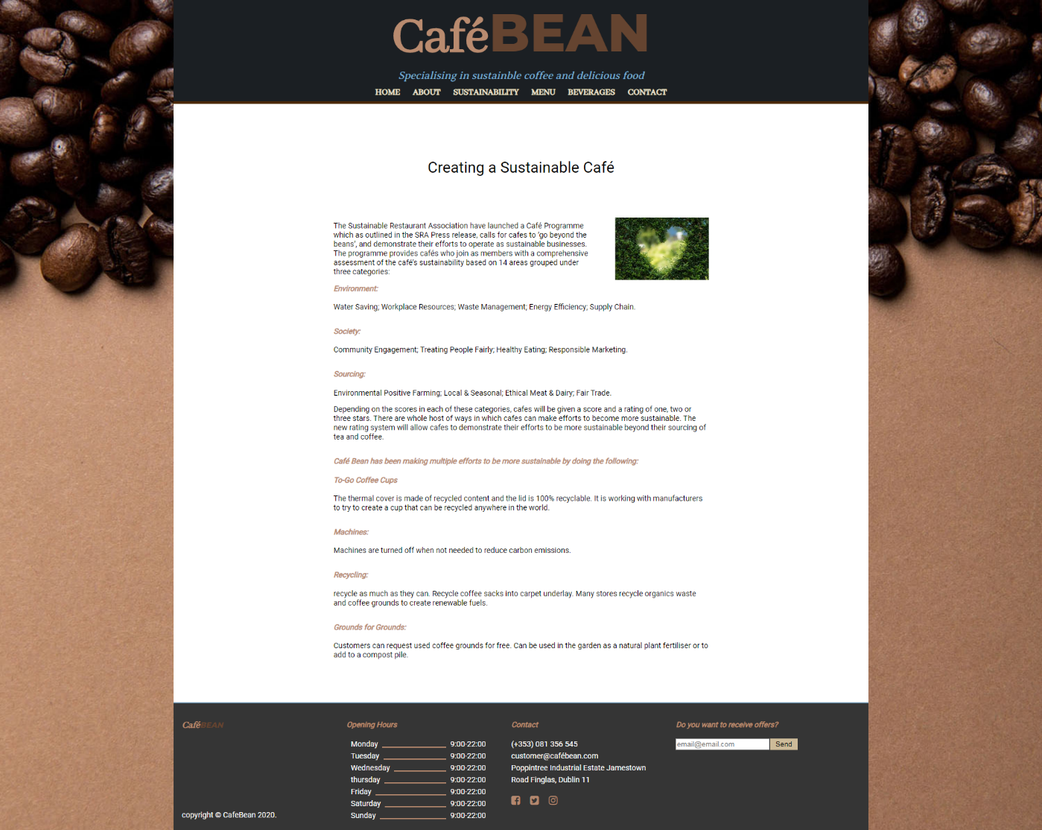

Desktop - Sustainability

*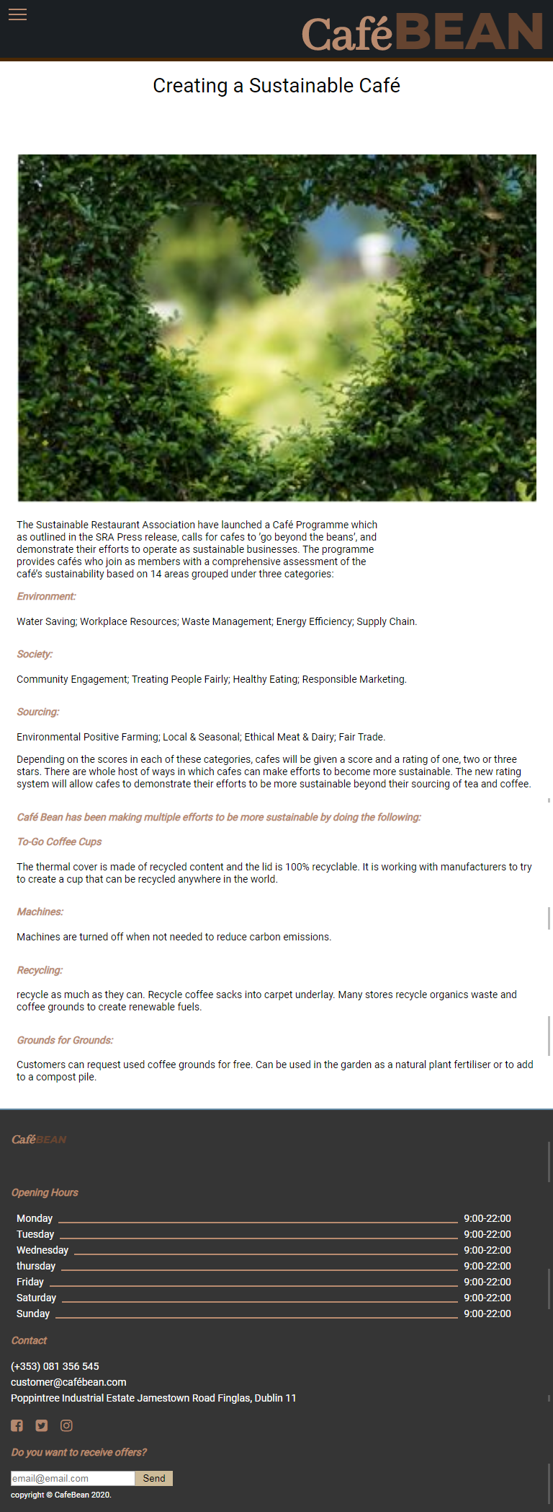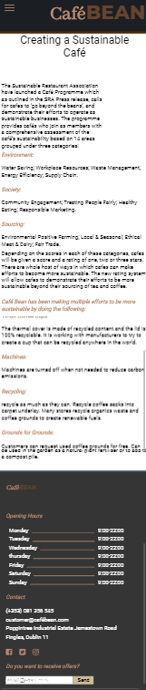*

Tablet Sustainability

Mobile Sustainability

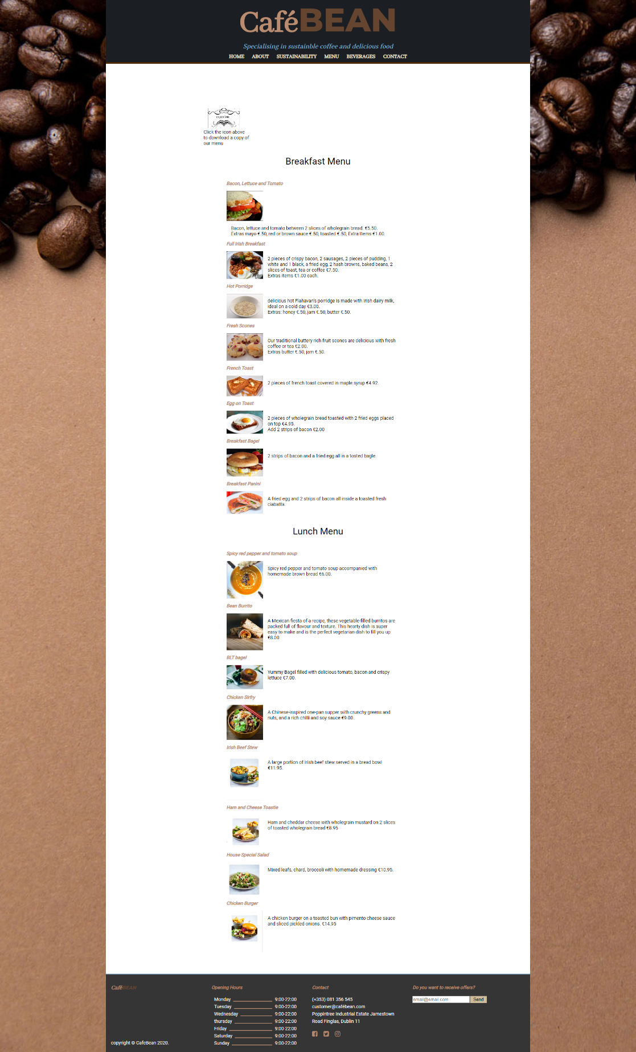

Desktop Menu

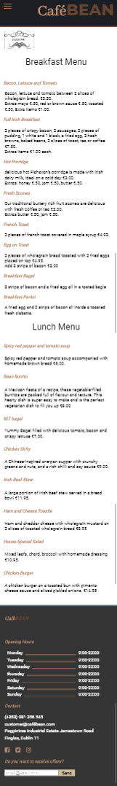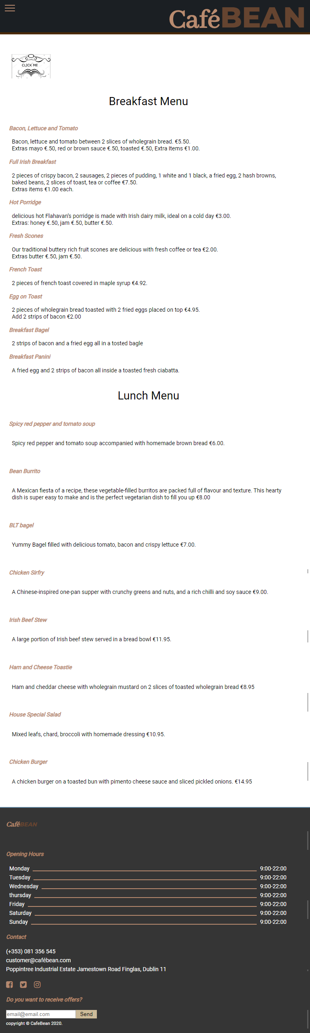

Mobile Menu

Tablet Menu

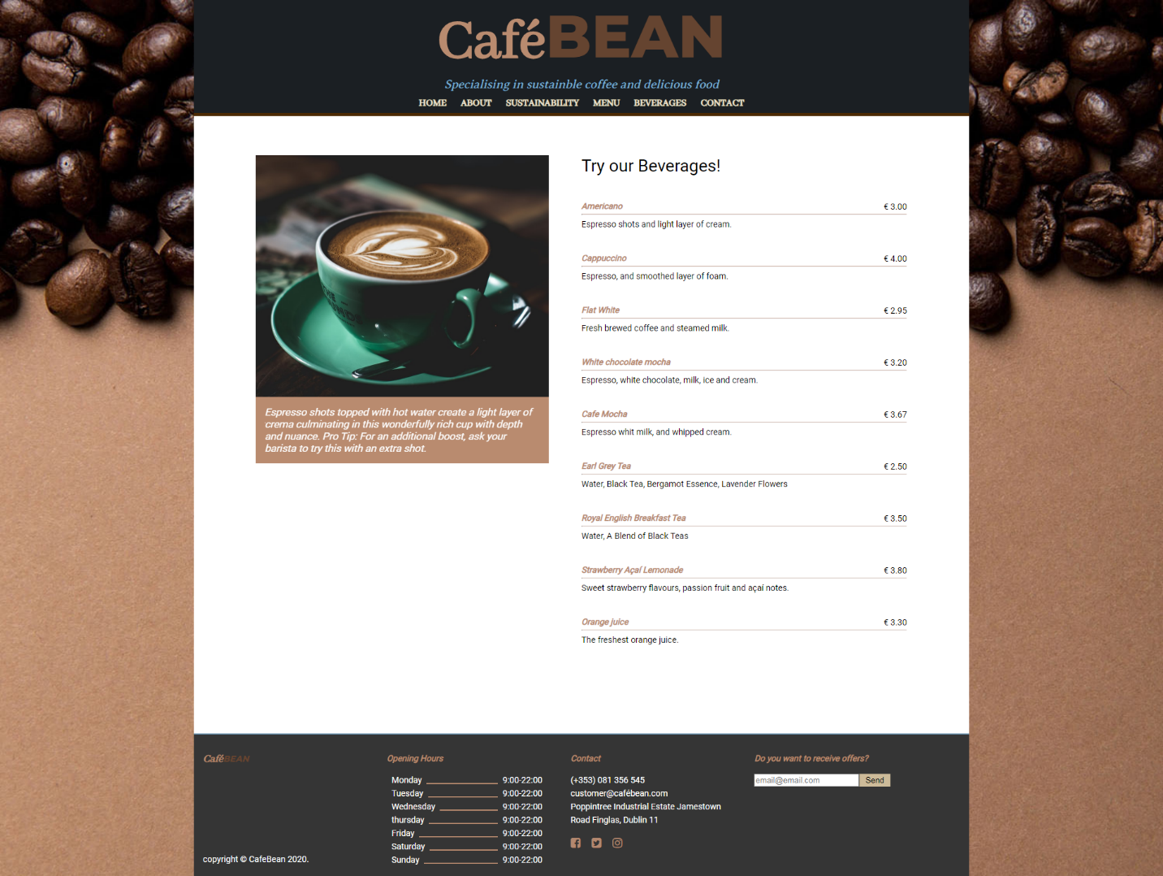

Desktop Beverages

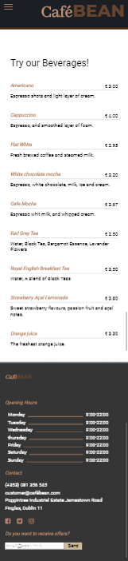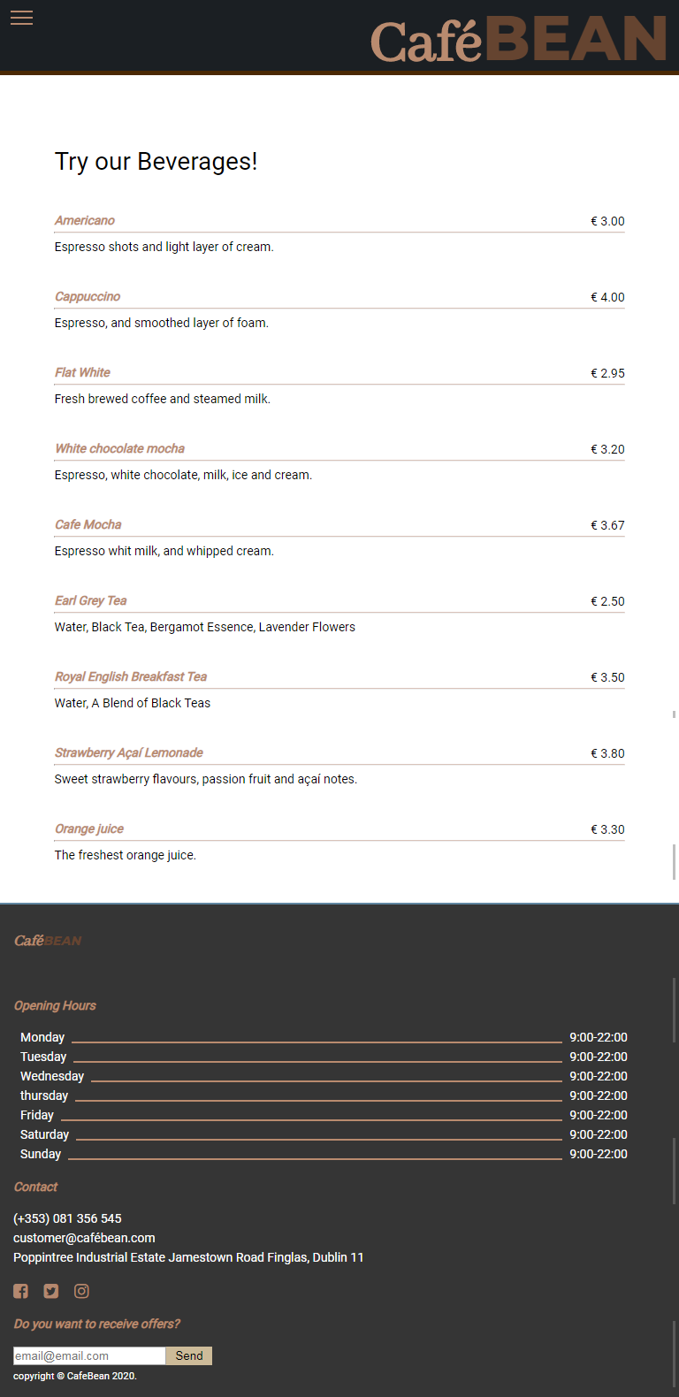

Mobile Beverages

Figure 1Tablet Beverages

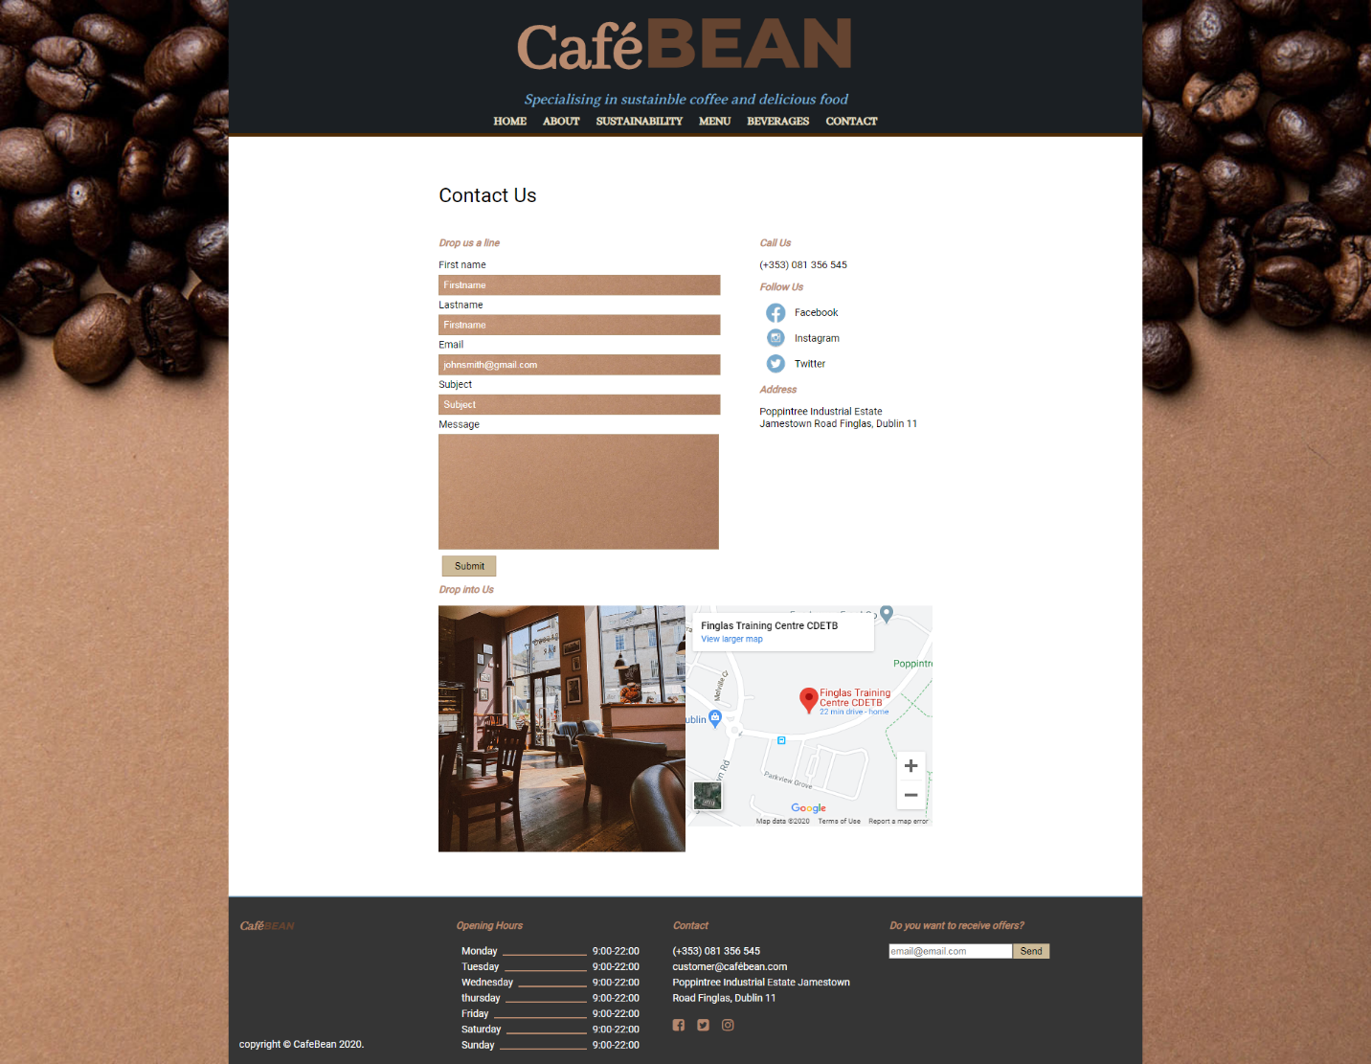

Desktop Contact

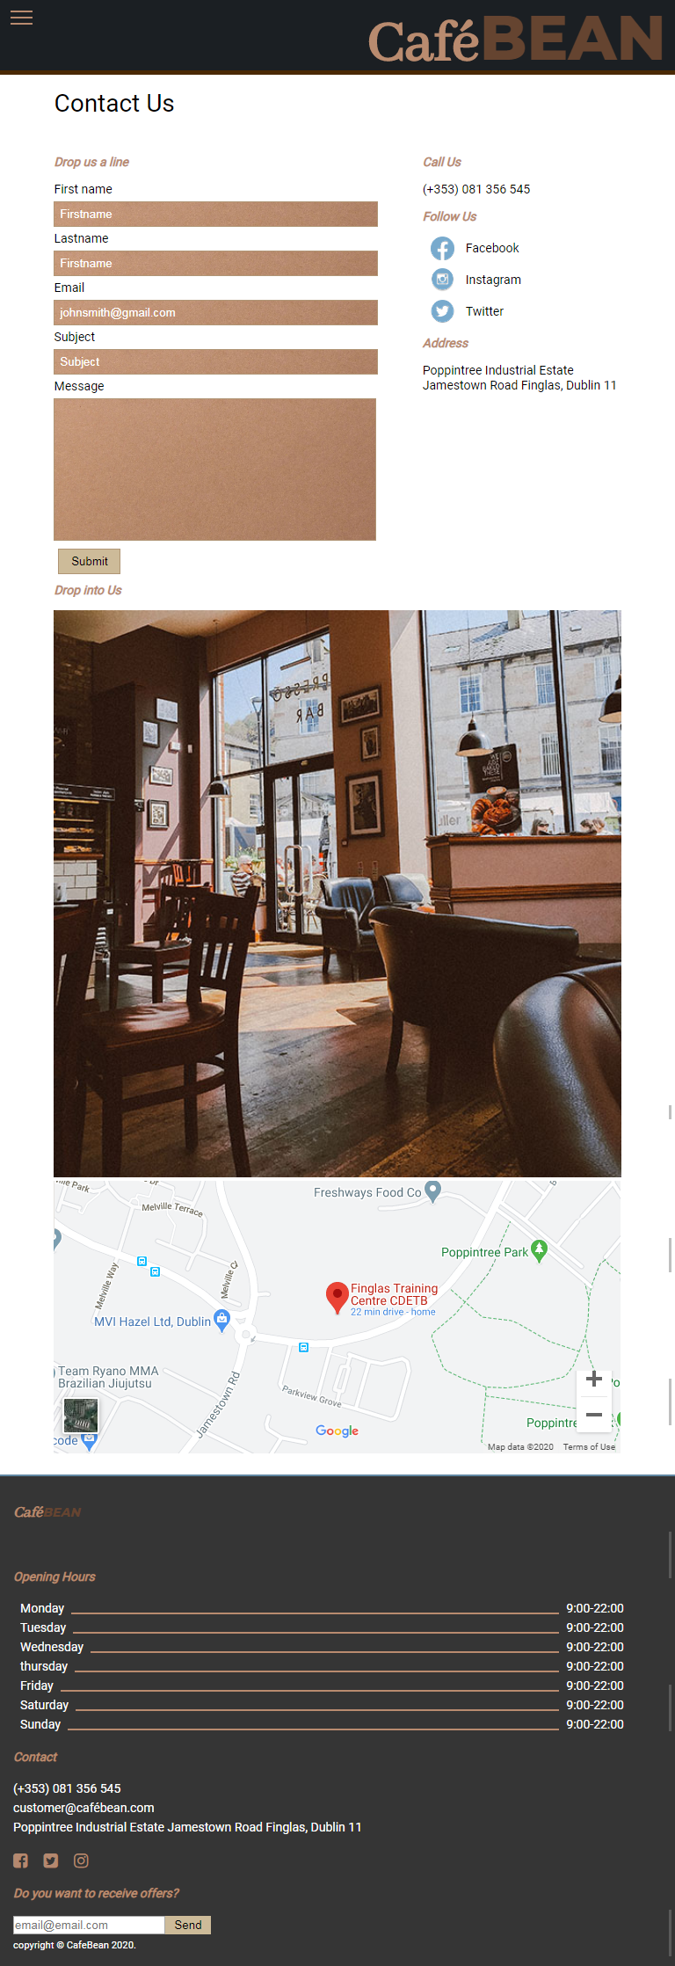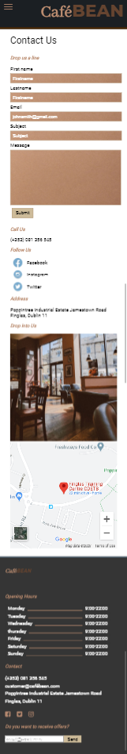Mobile Contact

Tablet Contact